
+University College Dublin
An Coláiste Ollscoile Baile Átha Cliath

SEMESTER I EXAMINATION – 2009/2010

COMP 20040 - RESIT

Data Structures and Algorithms II

Prof. V. Callaghan

Prof. J. Carthy

Dr. R. Collier*

Time allowed: 2 hours

Instructions for candidates

Answer any 2 questions.

1. Answer parts (a) to (e). 50 marks in total
- Define the important features of a Binary Search Tree.
(5 marks)

- Draw the Binary Search Tree obtained by inserting the following items in the order given:
15, 7, 12, 3, 18, 6, 2, 8, 9, 1
(10 marks)

- Give psuedo code for searching of Binary Search Trees.
(10 marks)

- Describe how a node is removed from a binary search tree. Illustrate your answer by showing what the tree in part (b) will look like after 3 is removed, and then after 12 is removed (i.e. you must draw 2 trees).
(15 marks)

- Discuss the performance of Binary Search Trees.
(10 marks)

2. Answer parts (a) to (d). 50 marks in total
- What is an AVL Tree? Draw the AVL Tree that would result from the insertion of the following items, in the order presented.
15, 7, 12, 3, 18, 6, 2, 8, 9, 1
(15 marks)

- Describe, how a node is inserted into an AVL Tree. Include a discussion of how the tree is restructured and the pseudo code for removal (you may assume the existence of a restucture(x) algorithm). Illustrate your answer by adding 24 to the tree below.

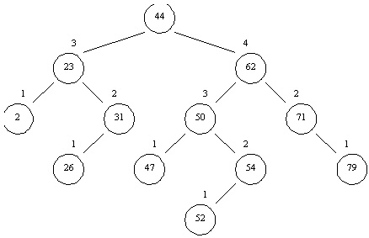

(20 marks)

- Explain how a node is removed from an AVL Tree. Illustrate your answer by removing 62 from the tree presented in part (b).
(15 marks)
3. Answer parts (a) to (d). 50 marks in total
- One ADT covered in the course is the Map ADT. Explain how this ADT works, and list the operations are normally associated with it.
(16 marks)

- One approach to the implementation of the Map ADT is Hash Tables. What is a Hash Table? Include in your answer a description of the main components that make up a Hash Table.
(10 marks)

- A Hash Table implementation for storing entries whose keys are integer values consists of an array of size 11 and a hash function h(x) = (4x + 3) mod 11. In addition, the Hash Table uses linear probing to handle collisions. Show using a diagram, the state of this Hash Table after each of the following keys has been added: 15, 7, 12, 3, 18, 6, 2, 8, 9, 1.
(10 marks)

- If given the task of building a Hash Table that will store entries whose keys are Strings, what Hash Code map would you use? Describe this hash code map, and generate hash codes for the following Strings:
- “happy”
- “dog”
- “god”
(14 marks)

4. Answer parts (a) to (c). 50 marks in total

- Given a graph with n vertices and m edges, what is the upper bound for m in an undirected graph with no self-loops and multiple edges.
(3 marks).

- There are three main approaches to implementing a graph. Describe each approach, illustrating your answer with a diagram that highlights the design underlying that approach.
(15 marks).

- Compare the performance of each of the approaches outlined in (b) with respect to the following issues:
    - Space (Memory)
    - incidentEdges(v) method
    - areAdjacent(v,w) method
    - insertVertex(o) method
    - insertEdge(v, w, o) method
    - removeVertex(v) method
    - removeEdge(e) method
(7 marks).

- What is a Minimal Spanning Tree? Describe and prove the cycle and partition properties of Minimal Spanning Trees.
(10 marks).

- Give psuedo code for Prim-Jarnik’s Algorithm for finding the Minimal Spanning Tree of a weighted graph, and use this algorithm to find the Minimal Spanning Tree of the graph below.
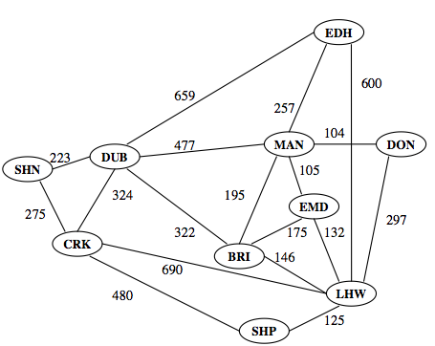
(15 marks).

